**ST. XAVIER’S COLLEGE**

**Maitighar, Kathmandu**



Data Base Management System Theory Assignment #4

**Submitted by**

Yub Raj Basnet

013BScCSIT048 (4th Semester)

**Submitted to**

|  |  |
| --- | --- |
| Er. Sanjaya Kumar Yadav  (Lecturer, St. Xavier’s College ) |  |

# E-R DIAGRAM WITH ONE CASE STUDY:

Definition:

ER-modeling is a data modeling technique used in software engineering to produce a conceptual data model of a information system. Diagrams created using this ER-modeling technique are called Entity-Relationship Diagrams, or ER diagrams or ERDs. So you can say that Entity Relationship Diagrams illustrate the logical structure of databases.

There are three basic elements in ER-Diagrams:

1. Entities are the "things" for which we want to store information. An entity is a person, place, thing or event.
2. Attributes are the data we want to collect for an entity.
3. Relationships describe the relations between the entities.

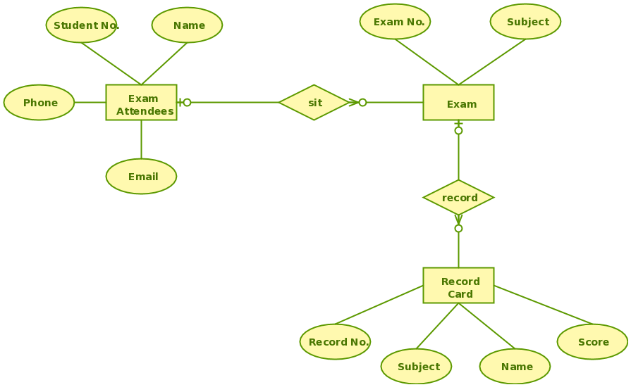

Fig: EXAM DATABASE E-R DIAGRAM

# DESIGN:

Functional design

Data Base Design

Conceptual DataBase design

Logical DataBase design

Physical Data Base Design

# CHARACTERISTIC OF RELATION

# E-R TO RELATIONAL MAPPING ALGORITHM

Step 1: Mapping of Regular Entity Types.

* For each regular (strong) entity type E in the ER schema, create a relation R that includes all the simple attributes of E.
* Choose one of the key attributes of E as the primary key for R.
* If the chosen key of E is composite, the set of simple attributes that form it will together form the primary key of R.
* Example: We create the relations EMPLOYEE, DEPARTMENT, and PROJECT in the relational schema corresponding to the regular entities in the ER diagram.
* SSN, DNUMBER, and PNUMBER are the primary keys for the relations EMPLOYEE, DEPARTMENT, and PROJECT as shown

Step 2: Mapping of Weak Entity Types

* For each weak entity type W in the ER schema with owner entity type E, create a relation R & include all simple attributes (or simple components of composite attributes) of W as attributes of R.
* Also, include as foreign key attributes of R the primary key attribute(s) of the relation(s) that correspond to the owner entity type(s).
* The primary key of R is the combination of the primary key(s) of the owner(s) and the partial key of the weak entity type W, if any.
* Example: Create the relation DEPENDENT in this step to correspond to the weak entity type DEPENDENT.
* Include the primary key SSN of the EMPLOYEE relation as a foreign key attribute of DEPENDENT (renamed to ESSN). The primary key of the DEPENDENT relation is the combination {ESSN, DEPENDENT_NAME} because DEPENDENT_NAME is the partial key of DEPENDENT.

Step 3: Mapping of Binary 1:1 Relation Types

* For each binary 1:1 relationship type R in the ER schema, identify the relations S and T that correspond to the entity types participating in R.
* There are three possible approaches:

1) Foreign Key approach: Choose one of the relations-say S-and include a foreign key in S the primary key of T. It is better to choose an entity type with total participation in R in the role of S.

Example: 1:1 relation MANAGES is mapped by choosing the participating entity type DEPARTMENT to serve in the role of S, because its participation in the MANAGES relationship type is total.

2. Merged relation option: An alternate mapping of a 1:1 relationship type is possible by merging the two entity types and the relationship into a single relation. This may be appropriate when both participations are total.

3. Cross-reference or relationship relation option: The third alternative is to set up a third relation R for the purpose of cross-referencing the primary keys of the two relations S and T representing the entity types.

Step 4: Mapping of Binary 1:N Relationship Types.

* For each regular binary 1:N relationship type R, identify the relation S that represent the participating entity type at the N-side of the relationship type.
* Include as foreign key in S the primary key of the relation T that represents the other entity type participating in R.
* Include any simple attributes of the 1:N relation type as attributes of S.

Step 5: Mapping of Binary M:N Relationship Types.

* For each regular binary M:N relationship type R, create a new relation S to represent R.
* Include as foreign key attributes in S the primary keys of the relations that represent the participating entity types; their combination will form the primary key of S.
* Also include any simple attributes of the M:N relationship type (orsimple components of composite attributes) as attributes of S.

Step 6: Mapping of Multivalued attributes.

* For each multivalued attribute A, create a new relation R.
* This relation R will include an attribute corresponding to A, plus the primary key attribute K-as a foreign key in R-of the relation that represents the entity type of relationship type that has A as an attribute.
* The primary key of R is the combination of A and K. If the multivalued attribute is composite, we include its simple components

Step 7: Mapping of N-ary Relationship Types.

* For each n-ary relationship type R, where n>2, create a new relationship S to represent R.
* Include as foreign key attributes in S the primary keys of the relations that represent the participating entity types.
* Also include any simple attributes of the n-ary relationship type (or simple components of composite attributes) as attributes of S.

# EXAMPLE:

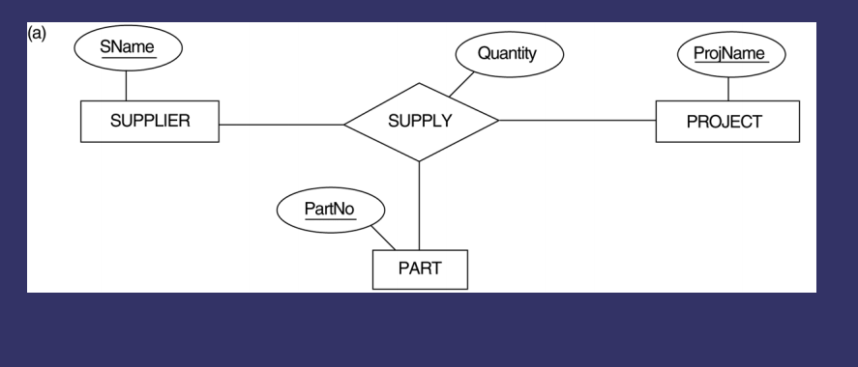

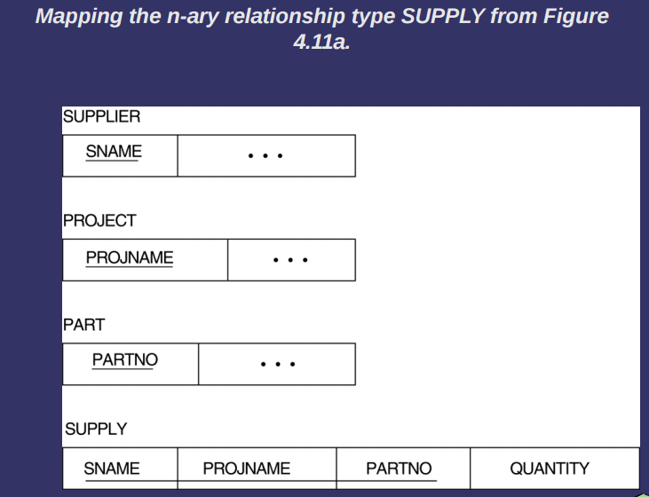

# REFERENCE

<http://home.iitj.ac.in/~ramana/ch7-mapping-ER-EER-relations.pdf>

http://creately.com/diagram/example/gsv8l5hs2/Exam+Database